## TEAM { Blaze }

### Console game for C Sharp - part 2

# MEMBERS

## Including usernames from the student system

|  |  |  |  |
| --- | --- | --- | --- |
| FULL NAME: | USERNAME: | STATUS: | RESPONSIBILITIES |
| Vasil Nikolov | eqinox | *Active* | *Code management, TFS server* |
| Dimitar Atanasov | Sir_EFO | *Active* | *Code* |
| Jivko Todorov | jiwko22 | *Left the team, due personal reasons* | *-* |
| Martin Vatev | Mart1n_Vatev | *Active* | *Code, Idea of the game* |
| Nikola Georgiev | niksy | *Active* | *Code* |
| Petur Krustanov | Petur_Krustanov | *Active* | *Code* |
| Petar Minkov | kabachef | *Active* | *Code, documentation support* |
| Plamen Georgiev | cchapo | *Left the team, due unknown reasons, no feedback* | *-* |
| Polina Petrova | aluin | *Active* | *Design, Name of the game, Documentation* |
| Tanya Marinova | tanya.marinova1 | *Busy but willing to help* | - |

# **PROJECT** EXPLANATION

## describtion

We decided to develop a game for training brain speed. It’s very easy to play. You just need to write down the falling words in a text field as fast as possible. The great plus is that the game is very educational and checks how quickly your brain can process events around you and determines how effectively you can react to and remember those events.

Words are not random, they are a part of ***A NEW GENERAL SERVICE LIST*** made from Paul Nation, Dr. Charles Browne, Dr. Brent Culligan and Joseph Phillips. They have worked together to create a new General Service List (NGSL) of important vocabulary words for students of English as a second language. First published in early 2013, these 2800 + words provide an astonishing 90% coverage of general English texts.

* There are **7 LEVELS**
* 2 types of **COMBOS**:

- If you type a word less than 3 seconds your score is ***+ 3x***

- If you type a word less than 6 seconds your score is + ***2х***

* **SCORE**:

- Score is depending from a length of the word and from a “difficulty” of the charter, which is in it. Difficulty depends from frequency of the letters of the alphabet in English, according to <http://www.oxforddictionaries.com/>. They made an analysis of the letters occurring in the words listed in the main entries of the Concise Oxford Dictionary *(11th edition revised, 2004)*

- If you type a word with five letters you are scored 5 points. If it’s Combo: ***Length of the word * combo***

## Interface:

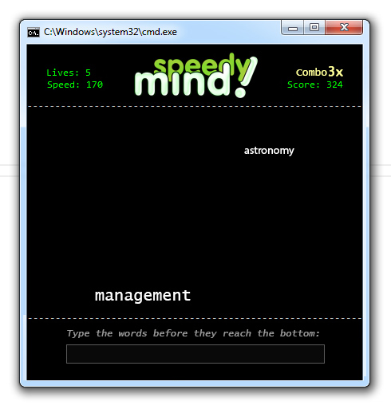

# **TFS** SERVER

## THE URL OF our TFS REPOSITORY

## <https://teamblaze.visualstudio.com/>

# OTHER INFORMATION

We have had very smooth communication and everybody from the active members was helpful and trustful. To cooperate our team better we had used Skype conference chat and Google docs.

Here is the link to our doc:

## [https://docs.google.com/document/d/1kDhJ9T36hxRpYQD2Zq-NxC2uWcT6_dvTqIgP8tLfWzQ/edit#](https://docs.google.com/document/d/1kDhJ9T36hxRpYQD2Zq-NxC2uWcT6_dvTqIgP8tLfWzQ/edit)